Name:__________________________________ Due: Tuesday Week 3

- From a normal deck of 52 playing cards, one card is chosen. Find the probability of choosing (remember, simplify fractions where possible);

  - a red card (e) a king
  - a royal (f) the ace of spades
  - a 3 or a 4, except the 4 of diamonds (g) anything other than a club

  - not the 2 or 3 of hearts (h) not a diamond or a 5

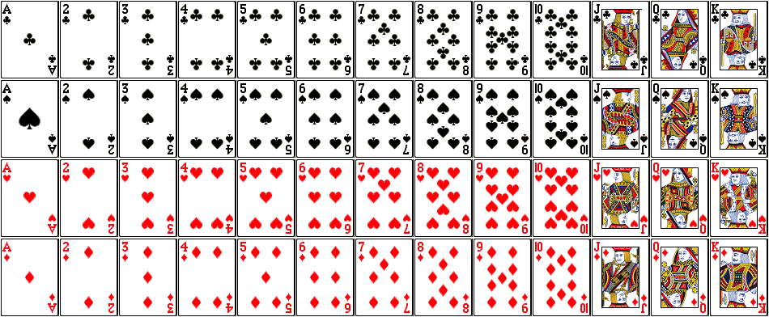

- A tree diagram is shown below represents a coin tossed 3 times.

- Why is it a better to display this as a tree diagram rather than a two-way table?

- What is the theoretical probability of;
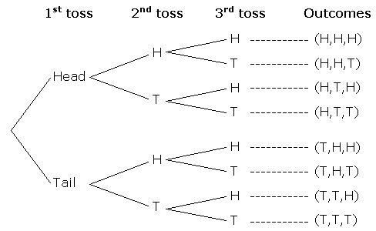
- All heads

- At least one tail

- Two tails

- One or two heads

- Not two heads and a tail

- Tails on the second toss

- Two fair dice are thrown, one blue and one red. A total is worked out by subtracting whichever die has the lowest number from whichever has the highest number (if the same number is rolled, the result is zero).

- Display all the possible totals using a two-way table.

- Does this represent theoretical or experimental probability? Why?

- Find the probability of;

- obtaining a total of 4 (iv) not obtaining a total of 5

- rolling a 6 and obtaining total of more than 3 (v) obtaining a total of 0

- rolling a 5 and obtaining an even total (vi) obtaining a total of 1 or 2

*Challenge Questions*

- Given that the total is more than 3, find the probability of;

- obtaining a total of 4 (iii) obtaining a total of 6

- not obtaining a total of 7 (iv) not obtaining a total of 2

